**PREMIUM LIST**

**AKC All-Breed AGILITY TRIALS**

**This Event is Accepting Entries for Mixed Breed Dogs**

**Enrolled in the AKC Canine Partners Program**

TYLER OBEDIENCE TRAINING CLUB

*(Licensed by the American Kennel Club)*

***Oct 29, 30 and 31, 2021***

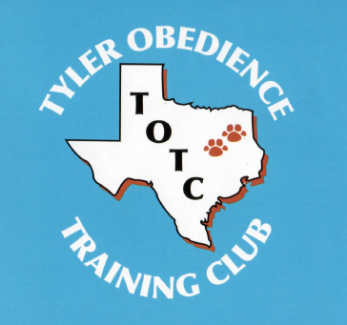

**LUCKY DOG TRAINING CENTER**

County Road 1134 (Old Chandler Hwy) Tyler TX 75709

Event numbers: 2021269201, 2021269202, 2021269203

Friday, Saturday & Sunday Oct 29, 30 and 31

Entry limits – 350 runs per judge, 350 runs per day

Walk thru beings at 8:15 AM on Friday, Saturday and Sunday

Trial Hours are Friday, Saturday & Sunday 7 AM until 6 PM

**Judge: Laura English**

Entry Method: First Received

**Equipment: Rubber contacts, plastic jump cups, electronic timing equipment and breakaway tire.**

**Air-conditioned/heated crating area & inside restroom – Covered Arena with packed dirt**

**ENTRIES WILL OPEN on 8/19/21 at 8:00 AM** at the Trial Secretary's address. All entries received before this date will be returned. Overnight or certified mail must be sent with the "No Signature Required" waiver signed.

**ENTRIES WILL CLOSE ON 10/15/21 at 5:00 PM** after which time entries cannot be accepted, cancelled, altered, or substituted except as provided for in Chapter 11, Section 6 of the Rules applying to Dog Shows. Envelopes/ transactions containing entries for more than the ten (10) maximum and/or entries received prior to the opening date shall be treated as invalid entry and shall be returned to the sender.

|  |  |
| --- | --- |
|  | Permission is granted by the American Kennel Club  for the holding of this event Under American Kennel  Club Rules and Regulations.  *James P. Crowley, Secretary* |

Tyler Obedience Training Club

Officers and Board

|  |
| --- |
| President………………………………………………………………………………………………………..Kathleen McCollough |
| Tyler, TX |
| Vice-President…………………...………………………………………………………..……….……………….….Becky Barnes |
| Golden, TX |
| Treasurer………………………………………………………………………………………………….….…………... Sonja Asido |
| Mineola, TX |
| Secretary………………………………………………………………………………………………….………………. Marcy Vail |
| Mineola, TX |

**Event Committee**

Kim Whaley, Monica Adkins, Cyndy Edwards, Cheryl Etheridge, Angela Hudson, & John Parsons

|  |  |
| --- | --- |
| **Trail Chairperson**  Angela Hudson  16361 Cattle Baron Dr  Lindale, TX 75771  Cell: 903-570-3852  Zoemoppett1@yahoo.com | **Trial Secretary**  Monica Adkins  7310 Sandy Hill Ln  Murchison, TX 75778-2972  Phone: 903-681-2458  Maillady08@embarqmail.com |

**Judge and Assignment**

|  |  |  |  |
| --- | --- | --- | --- |
| **Judge** | **(Fri)** | **(Sat)** | **Sun)** |
| Laura English  Evansville, IN  AKC#26736 | Excellent/Masters, Open & Novice:  Fast,  Premier Standard,  Standard,  Premier JWW,  JWW  T2B | Excellent/Masters, Open & Novice:  Fast,  Premier Standard,  Standard,  Premier JWW,  JWW  T2B | Excellent/Masters, Open & Novice:  Fast,  Standard,  JWW |

**Running Order Above**

*The above is tentative running order, a finalized running order will be emailed out upon closing. All classes will be run tall to small and walk through splits will be indicated in the final confirmation*:

Check in Friday, Saturday & Sunday will be at 7 am – Walk thru at 8:15am

Please consult the AKC regulations for agility Trials for a complete description and eligibility for entry into these classes. The exhibitor is fully responsible for entering the dog in the correct class(es)/height divisions. Dogs running in a lower height division than they are eligible for will be eliminated.

**Emergency Vet**

On call Veterinarian: Tyler Animal Emergency Clinic -1401 W SW Southwest Loop 323 - Tyler TX 75701 (903)-534-0459

**Height Divisions**

|  |  |  |
| --- | --- | --- |
| **Regular** | **Preferred** | **Height at Withers** |
| Handlers may opt to run their dog in a higher height division. | Handlers must run their dog in their proper eligible height. | Owners are responsible for entering their dog in the proper height division. |
| 8” | 4” | For dogs 11 inches and under at the withers |
| 12” | 8” | For dogs 14 inches and under at the withers |
| 16” | 12” | For dogs 18 inches and under at the withers |
| 20” | 16” | For dogs 22 inches and under at the withers |
| 24” | 20” | For dogs over 22 inches at the withers |
| 24C” | n/a | Dogs under 22 inches may be entered at this height at their owner’s discretion |

**Dogs Eligible to Enter**

**This trial is open to all dogs fifteen (15) months of age or older that are registered with the American Kennel Club or are registerable breeds that have obtained an AKC, ILP, or PAL number. Mixed breed dogs that have been listed with the AKC Canine Partners may participate provided their listings number has been recorded on the entry form. Dogs should be physically sound. Dogs that are blind or deaf shall not be eligible, and neither are bitches in season, aggressive dogs, or dogs suffering from any deformity, injury or illness which may affect the dog’s physical or mental performance. No dog shall compete if it is taped or bandaged in any way or has anything attached to it for medical purposes. Puppies under six months of ate are strictly prohibited from the trial grounds.**

**Wait List Information**

In the event the trial fills, we are offering a Wait List to fill openings created by withdrawn entries after the trial’s closing date/time. A maximum of FIFTY (50) entries will be placed on the club’s wait list. **All entries, including wait list entries, must be received by the Trial Secretary prior to the trial closing date as listed on the front of this Premium. Any withdrawals that are received by 6:00 pm the Sunday prior to the first day of the trial will be replaced by a wait list entry if any are available.** If a withdrawn entry is replaced by a wait list entry, a full refund will be issued for the withdrawn entry. Any wait listed entry that does not move off the wait list into the trial by 6:00 pm the Sunday prior to the first day of the trial will receive a full refund.

**Obstacles and Ring Conditions**

Obstacles will meet the specifications for obstacles in the current edition of the Regulations for Agility Trials. **All classes will take place in a covered arena on a packed dirt surface.** Ring measurement will be 90’ W x 100’ L

**Entry Fees Per Day**

First Entry of each dog (includes $3.50 AKC recording fee) ………….$23

Second Entry of same dog (includes a $3.00 AKC recording fee) ……..$13

Third – sixth entry of same dog (includes $3.00 AKC recording fee) ….. $13

All confirmations will be emailed to a valid email address unless otherwise requested.

Mail entry forms and fees to: Monica Adkins 16361 Cattle Baron Dr. Lindale TX 75771 Please make checks payable to: Tyler Obedience Training Club (or TOTC). No entries will be accepted by phone, fax, or hand delivery. Express mail entries must include the signature waiver allowing them to be left at the secretary’s address. Inquiries may be directed to Monica Adkins at [maillady08@embarqmail.com](mailto:maillady08@embarqmail.com) or [agilitysecretaryAKC@tylerotc.org](mailto:agilitysecretaryAKC@tylerotc.org). No entry shall be made and no entry shall be accepted which specifies any conditions to its acceptance. Illegible entries will not be processed and will be returned to the exhibitor. Returned checks do not constitute a valid entry and the Trial Secretary will add a $30.00 collection fee to the amount of each returned check.

**Ribbons, Awards and Prizes**

Strip ribbons will be awarded in each jump height division in each class as follows:

*First Place……………………………………...……………...……………………….……….…..Blue*

*Second Place……………...……………………..…………………………………………………Red*

*Third Place……………………………………..…………………………………...……………Yellow*

*Fourth Place………………………………………………......…………………………..………White*

*Qualifying Score……………………………………………………..……………...…..…Dark Green*

A New Title rosette will be awarded to all dog and handler teams finishing a title. A MACH/PACH rosette and MACH/PACH bar will be awarded to all dog and handler teams that attain their MACH/PACH.

All exhibitors should obtain a copy of the Regulations for Agility Trials by downloading them from the American Kennel Club website at <http://www.akc.org/rules/>.

**NOTICE TO EXHIBITORS**

SAFETY, BEHAVIOR AND LIABILITY

The safety of the dog is our primary concern. By entering this trial, exhibitors acknowledge that they are familiar with the rules and regulations of this sport, and their dogs are familiar with and able to perform all obstacles safely.

It is expressly understood that exhibitors alone are responsible for the behavior of their dogs and/or children. Any exhibitor whose dogs and/or children create an unnecessary disturbance or repeatedly engage in unsafe or disruptive behavior may, at the discretion of the trail committee, be asked to leave the show site.

**All dogs must be on leash** at all times when on trial grounds except when in the designated warm-up area or competing on the course.

AVMA:  Exhibitors should follow their veterinarian’s recommendations to assure their dogs are free of internal and external parasites, any communicable diseases, and have appropriate vaccinations.

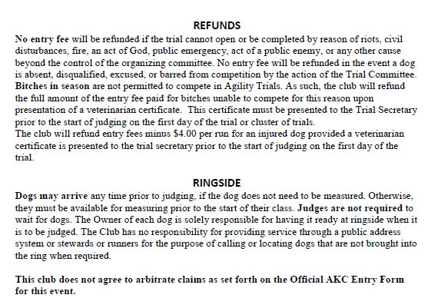

**MOVE UPS**

**Move ups must be submitted in writing (email is fine) no later than Monday, Oct 25th, 2021 at 5pm. Contact Monica at** [**Zoemoppett1@yahoo.com**](mailto:Zoemoppett1@yahoo.com) **OR** [**agilitysecretaryAKC@tylerotc.org**](mailto:agilitysecretaryAKC@tylerotc.org)**.**

**Day-to-day move ups will be allowed. Exhibitors must present the move-up form to the trail secretary no later than 30 minutes after the trial ends each day.**

**HOTELS AND MOTELS THAT ACCEPT DOGS**

Since hotel policies are subject to change, please be sure to inquire about current policies when making reservations. All hotels are within 15 minutes of the Lucky Dog Training Center.

|  |  |  |  |
| --- | --- | --- | --- |
| La Quinta Inn & Suites by Wyndham  McDonald Rd/University  Tyler, TX 75701  903-481-9880 | Baymont Inn & Suites  3913 Frankston Hwy  Tyler TX 75701  903-939-0100  **Dog Charge $5 per dog Ask for the Lucky Dog Training Center Rate** | La Quinta Inn- Tyler  2552 S SE Loop 323  Tyler, TX 75701  903-525-9677  **NOT RECOMMENDED** | La Quinta Inn & Suites by Wyndham  6702 S Broadway Ave  Tyler, TX 75703  903-561-0863  *Great food choices walking distance |

**Other Information**

**Food**

Several fast food restaurants within 3 miles of show site. No other on-site food vendors.

**Worker Raffle**

A worker raffle will be offered: each worker will receive raffle tickets to be used for items in the raffle and drawn each day.

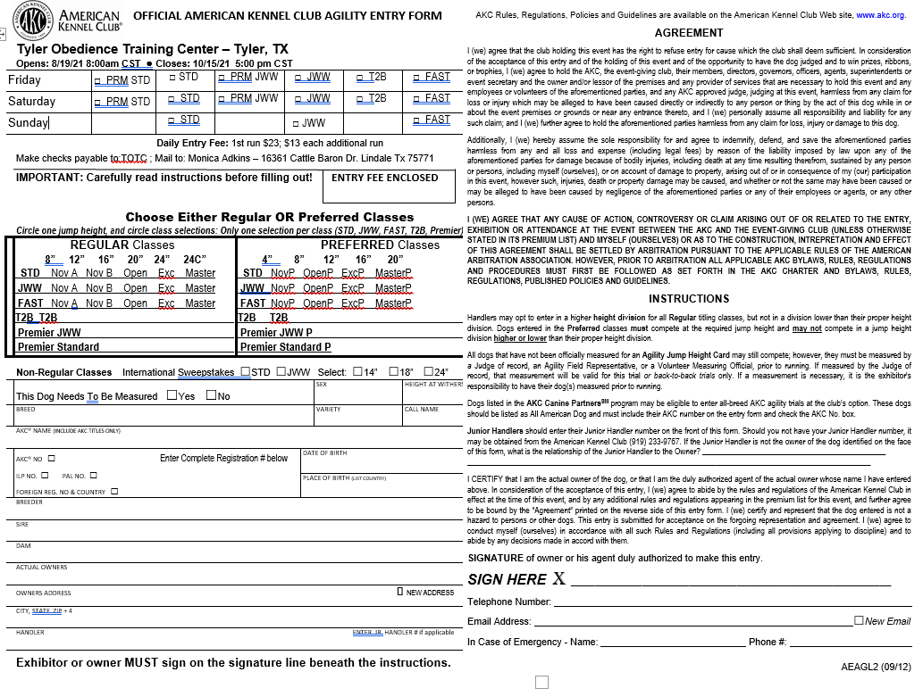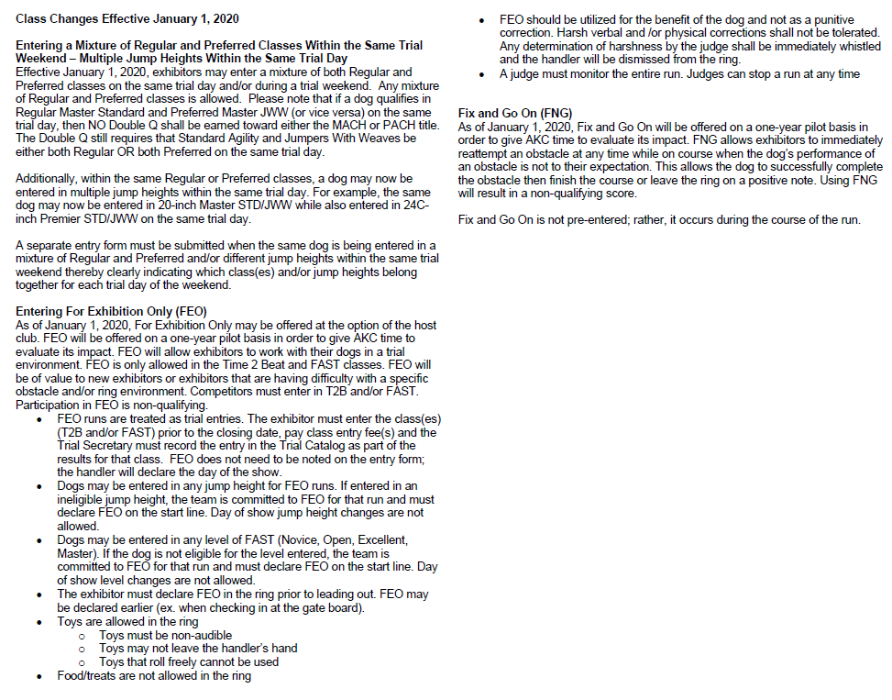

**Directions to Lucky Dog:**

Directions:    
  **from Tyler** - Follow Loop 323 around to the west side of town.  Take Spur 364 (west) to CR 1134 (across from the Tire Barn).  Turn south on CR 1134, go 2 miles, park is on left.  
  
  **from north or east of downtown Tyler** - take Loop 323 around the north side to HWY 31 west (headed to Chandler/Athens).  Turn left on Spur 364 (the light just past Scott’s plant).  Climb hill, turn south (right) on CR 1134, go 2 miles, park is on left.  
  
  **from south of LOOP 49** - take 155 to CR 2661.  Turn west on 2661, go 9 miles.  After crossing the railroad tracks, turn north on CR 1134.  Go 0.8 miles, park is on right.

